Acceptance
Accountability
Accountable Decisions
Accountable Leadership
Accuracy
Achievement
Adaptability
Adventure
Agility
Altruism
Ambition
Appreciation
Authenticity
Authority
Balance
Beauty
Being the best
Belonging
Boldness
Career
Caring
Charity
Civic Engagement
Collaboration
Commitment
Community
Compassion
Competence
Confidence
Connection
Contentment
Contribution
Constructive Feedback
Continuous Learning
Cooperation
Courage
Creativity
Credibility
Curiosity
Customer Focus
Customer Satisfaction
Dedication
Dependability
Determination
Discipline
Dignity
Diversity
Drive
Efficiency
Empathetic Listening
Empowerment
Empowerment of Others
Endurance
Enthusiasm
Environment
Environmental Stewardship
Equality
Ethical Practice
Ethics
Excellence
Excellence in Execution
Exploration
Expression
Fairness
Faith
Fame
Family
Financial stability
Flexibility
Forgiveness
Freedom
Friendliness
Friendship
Fun
Future generations
Generosity
Giving Back
Global Perspective
Grace
Gratitude
Growth
Harmony
Health
Holistic Approach
Home
Honesty
Hope
Humility
Humor
Inclusiveness
Inclusive Leadership
Inclusion
Independence
Initiative
Inner Harmony
Innovation
Integrity
Intuition
Job security
Joy
Justice
Kindness
Knowledge
Lawfulness
Leadership
Leading by Example
Learning
Legacy
Leisure
Lifelong Learning
Listening
Love
Loyalty
Making a difference
Mastery
Mentorship
Mindfulness
Motivation
Mutual Respect
Nature
Objectivity
Open Communication
Open Exchange
Open-mindedness
Openness
Optimism
Order
Parenting
Passion
Patience
Patriotism
Peace
Peer Recognition
Perseverance
Personal fulfillment
Personal Growth
Personal Integrity
Positivity
Positive Attitude
Positive Change
Power
Preparedness
Pragmatism
Pride
Professionalism
Punctuality
Purpose
Purpose-Driven
Quality
Recognition
Reliability
Religion
Reputation
Resilience
Resourcefulness
Respect
Responsibility
Results-Orientation
Risk-taking
Safety
Satisfaction
Security
Self-Awareness
Self-Discipline
Self-Expression
Self-Respect
Serenity
Service
Service Orientation
Shared Success
Simplicity
Social Responsibility
Spirituality
Sportsmanship
Stewardship
Strategic Thinking
Success
Support
Sustainability
Synergy
Teamwork
Thrift
Time
Tolerance
Tradition
Transparency
Travel
Trust
Trustworthiness
Truth
Understanding
Uniqueness
Unity
Usefulness
Vision
Vulnerability
Wealth
Well-being
Wellness
Wholeheartedness
Wisdom
Work-Life Balance

Relationship Trust Behaviors Self-Assessment Activity

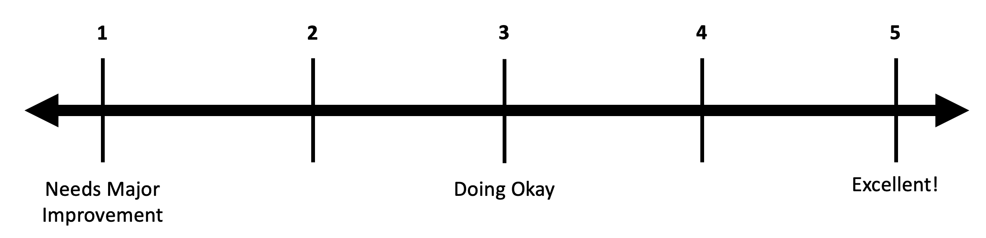

- How well do I Talk Straight - speak honestly and clearly, avoiding manipulation or distortion?
- How consistently do I Demonstrate Respect - show genuine care and concern for others in my words and actions?
- To what extent do I Create Transparency - share information openly and act with genuine intent?
- How effectively do I Right Wrongs - acknowledge my mistakes and make amends?
- How often do I Show Loyalty - give credit to others and speak about people as if they were present?
- Do I Deliver Results - consistently achieve the outcomes I’ve promised?
- How actively do I Get Better - seek feedback and strive for continuous improvement?
- How willing am I to Confront Reality - address difficult issues directly and constructively?
- Do I Clarify Expectations - make sure goals, roles, and deliverables are clear to all involved?
- How well do I Practice Accountability - hold myself and others responsible for results?
- How well do I Listen First - genuinely seek to understand before being understood?
- How reliably do I Keep Commitments - follow through on promises, large or small?
- How comfortable am I to Extend Trust - give trust to others and encourage them to do their best?
For each question, rate yourself from 1 (Needs Major Improvement) to 5 (Doing Great!)
Total: _________
Average (Total / 13): _________
Challenge: Find the item with your lowest score. What are you going to change over the next year to increase that by 1? Share with your group.

